

**UNIVERSITY OF PETROLEUM & ENERGY STUDIES**

**SCHOOL OF COMPUTER SCIENCE**

***Department of Cybernetics***

**GRAPHICS AND ANIMATIONS TOOLS**

LAB FILE

SESSION(2020-21)

Course: BTech with specialization in Open Source & Open Standards

Submitted to: Submitted by:

Dr. Durgansh Sharma Mridul Thapa

Associate Professor SAP: 500060077

Department of Cybernetics Roll no: R100217*039*

**VIVA-ASSIGNMENT**

**1)Aim -** Create a logo of any water bottle brand.

**Steps followed:**

1. Open GIMP.

2. Inside GIMP, create a new layer with white background(1080x1080 px).

3. Open an image of bottle as layers in GIMP and create a new transparent layer to draw water bottle.

4. Use the ‘Paths tool’ over the image and start selection boundaries and layout of the image.

5. After selection of layout/ boundaries, go to ‘Select’, choose ‘From Path’ option and your path will be selected.

6. After path is selected click on ‘bucket fill tool’ from the toolbar and color the bottle with your desired color.

7. Repeat step 3,4,5 for creating the cap of the water bottle.

8. Structure of water bottle is complete, now go to ‘Text tool’ and write name of the brand that you want for your bottle.

9. Use your creativity to style your text and when you feel it’s good, then place is at the desired location.

10. For adding the base/ table, cover the boundaries of the bottle and the white background using ‘Paths tool’ and then fill color in it using ‘bucket fill tool’.

11. Additional: Import logo of that brand and add it at the center of the bottle.

**OUTPUT-**

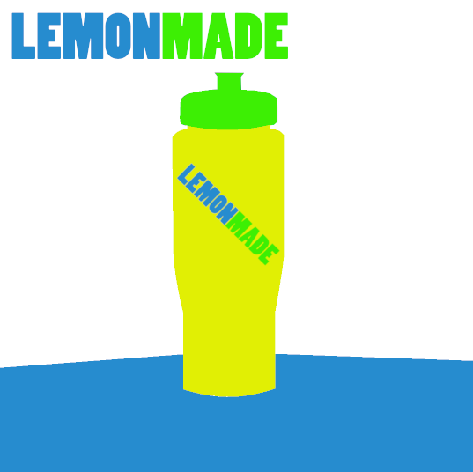

**2) Aim -** Create a hand sanitizer using Blender

**Steps followed:**

1. Draw a circle at an axis.

2. Again draw a bigger circle, join both circles with the Loft tool.

3. The surface of a bigger circle needs to extrude the same surface to make it a cylinder.

4. After that construct another circle at the surface of the cylinder.

5. Now make a smaller circle right above the cylinder with some height.

6. Loft the circles from step 4-5 to create a form.

7. From step 5 extrude the same circle to create a cylinder.

8. Now construct a small circle on the surface of the cylinders from Step7.

9. Apply the same steps as Step8 to construct a small cylinder.

10. Draw three different ellipse shapes to create a spray mechanism of sanitizer bottle.

11. At the end just give fillet to the cylinders you have a round finished edge to the bottle.

**OUTPUT:**

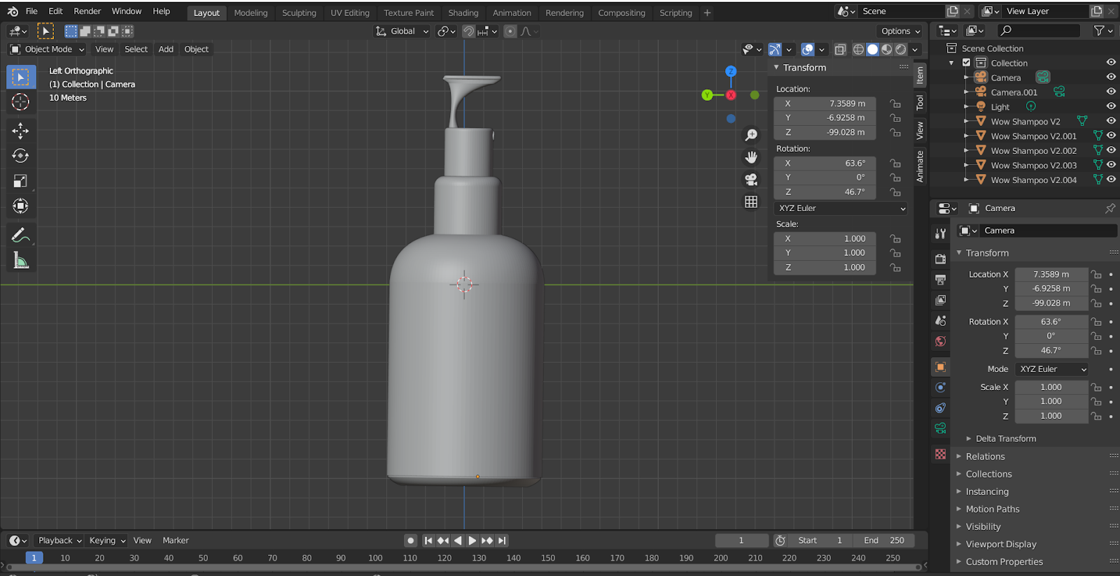

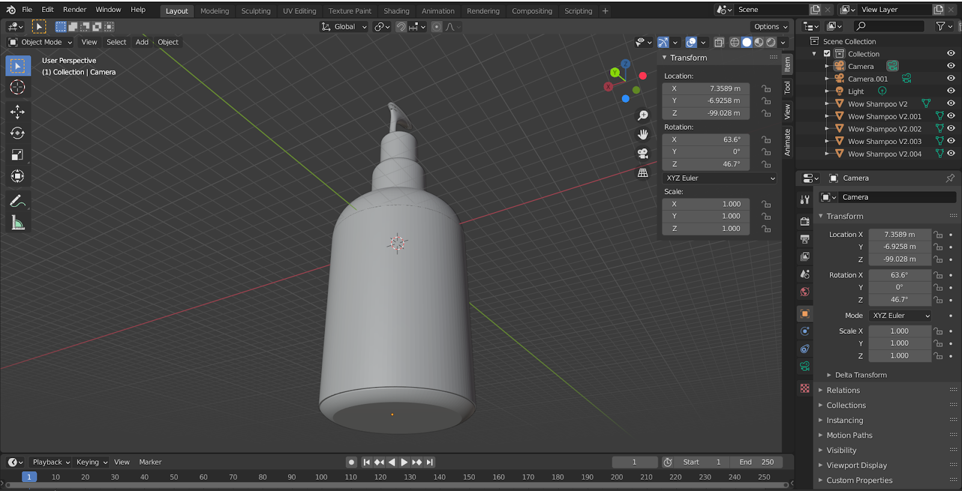

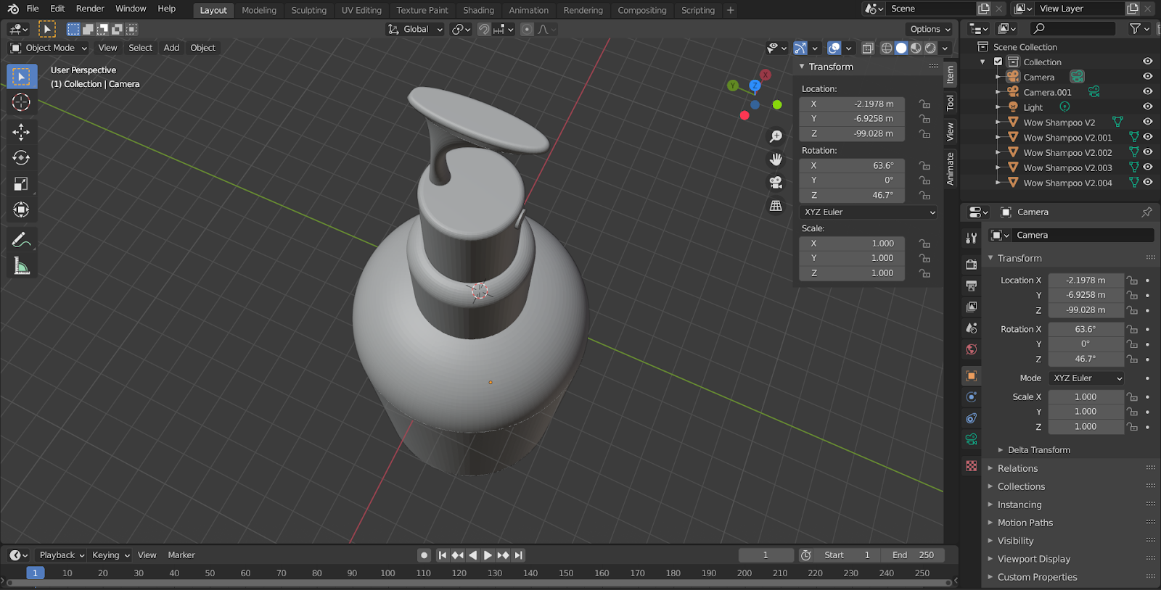

[**Link for the experiment file**](https://drive.google.com/drive/folders/1flTmZIImByf3y0i2nJoYBXPXMLePEHfe?usp=sharing)